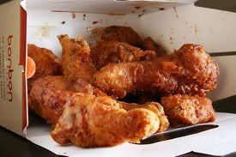

**Chicken Bon Bon**

* 2cups cooked and shredded Chicken
* Salt to taste
* 2 small sized Cucumber (Kheera)
* 1 tblsp Soya Sauce
* 3 tblsp Seasame Seeds
* 3 Red Chili (Lal Mirchi)
* 1 tblsp Vinegar (Sirka)
* 1 tsp crushed Black Pepper (Kali Mirch)
* 1 tsp powdered Sugar
* 1 tblsp chopped Spring Onions
* 1 tsp chopped Ginger (Adrak)

**Method :**

* Cut the cucumber into half length wise.remove the seeds and cut the cucumber into half.
* Divide the halved cucumber into length wise pieces approximately 1 inch in thickness. keep aside.
* Grind the red chillies in a blender along with the vinegar to a smooth paste. keep aside.
* Prepare the bon bon sauce by mixing in a basin the sesame oil, sesame seeds, salt , soya sauce, ginger, sugar, red chilly paste, crushed pepper corns and the spring onions.
* Mix thoroughly.